3rd September Assignment theory

1. Write difference between Truncate and delete

Delete is a DML command whereas truncate is DDL command. Truncate can be used to delete the entire data of the table without maintaining the integrity of the table. On the other hand , delete statement can be used for deleting the specific data.

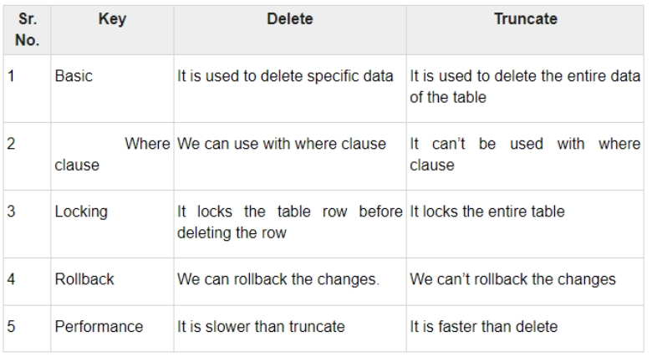

1. Write down difference between Truncate and drop
2. Write down the among truncate, Delete and drop

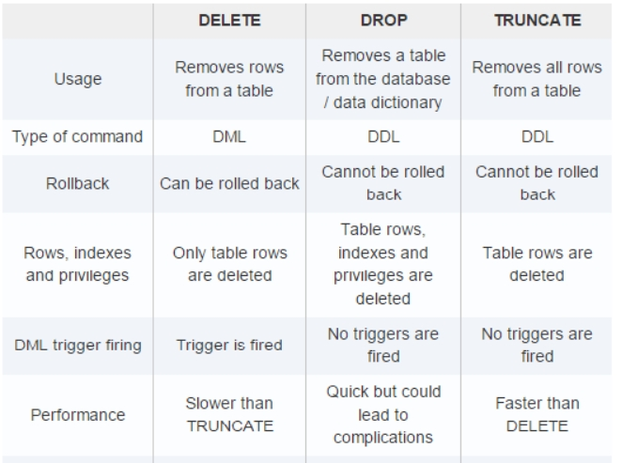

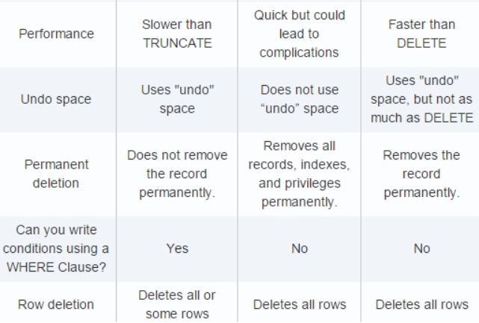

1. Find out the range of data types

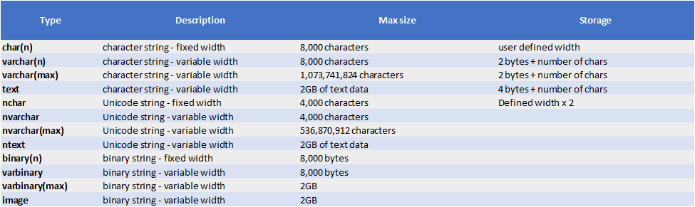

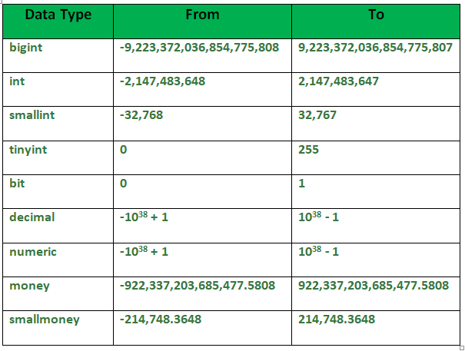

1. One line definition for below:

